**Mathematics in Data Science and Artificial Intelligence**

**Tanmoy Biswas**

**Student of Barishal University, Department of Mathematics**

btanmoybiswas169452@gmail.com

**Abstract:** Mathematics is a discipline that focuses on structure, order, and relation, derived from counting, measuring, and characterizing object shapes. Mathematics is necessary for professions in data science since machine learning algorithms, conducting analyses, and drawing conclusions from data all require it. A key component of data science is math. It can support problem-solving, model performance optimization, and the interpretation of complex data to address business-related queries. The technology known as artificial intelligence (AI) has come to revolutionize many facets of our existence. Mathematics plays a fundamental part in the astounding advances and capabilities of artificial intelligence. Mathematics contains various branches like algebra, geometry, Trigonometry, Calculus, Statistics and Probability. The foundation of mathematics gives artificial intelligence (AI) systems the ability to reason, learn, and make wise judgments. This article examines the relevance and use of mathematics in artificial intelligence. Large-scale data processing, analysis, and interpretation are made possible by machines thanks to mathematics, which forms the foundation of AI models and algorithms. Developing machine learning algorithms requires an understanding of concepts from statistics, probability theory, calculus, and linear algebra. These algorithms recognize patterns, forecast outcomes, and categorize data using mathematical equations and functions. Keywords: Mathematics, Data Science, Artificial Intelligence, Algorithms, Technology I.

**Keywords:** Mathematics, Data Science, Artificial Intelligence, Algorithms, Technology

**I. INTRODUCTION**

Mathematics is a crucial discipline in data science, focusing on structure, order, and relation. It is essential for machine learning algorithms, analysis, and drawing conclusions from data. Mathematics supports problem-solving, model performance optimization, and interpreting complex data to address business queries. Artificial intelligence (AI) has revolutionized various aspects of life, with its foundation in mathematics enabling systems to reason, learn, and make wise judgments. Mathematics contains various branches like algebra, geometry, Trigonometry, Calculus, Statistics and Probability. Mathematics is crucial in large-scale data processing, analysis, and interpretation, forming the foundation of AI models and algorithms. Understanding concepts from statistics, probability theory, calculus, and linear algebra is necessary for developing machine learning algorithms that recognize patterns, forecast outcomes, and categorize data using mathematical equations and functions [1]. The creation and effectiveness of intelligent systems depend heavily on the use of mathematics in AI. The concepts and techniques needed for AI systems to interpret data, identify trends, and reach well-informed conclusions are found in mathematics. The symbiotic relationship between mathematics and AI will be essential in opening up new avenues and prospects for creativity as AI develops and changes our environment. Artificial Intelligence (AI) has the ability to revolutionize businesses, resolve challenging issues, and improve our daily lives in amazing ways by utilizing the power of mathematics. Since the birth of the field, mathematics has been essential to the development of artificial intelligence, with mathematicians having a major role in its advancement. Considerable advancements have been made in fields including deep learning, optimization theory, and linear algebra. Human reasoning and cognition heavily rely on mathematics. It improves logical reasoning and is a useful method for developing mental discipline. Furthermore, knowledge of mathematics is necessary to comprehend concepts in other courses, including social studies, science, and even music and art. Numerous disciplines and fields use math. Mathematical ideas and methods are applied to engineering, science, and economics challenges .

**II. BRANCHES OF MATHEMATICS**

There are various components or fields of study in mathematics. Each section employs distinct techniques and addresses particular types of issues. Several significant branches consist of:

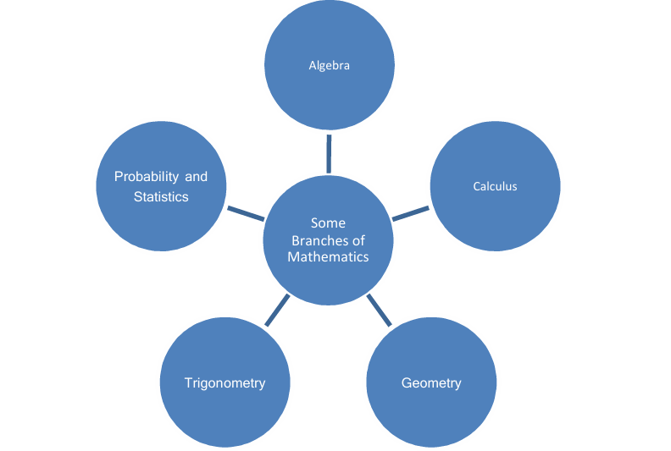

**• Algebra:** Algebra is an area of mathematics where formal manipulations and arithmetical operations are performed on abstract symbols as opposed to real numbers. The idea that there is such a thing as a separate branch of mathematics and the word algebra to refer to it came around gradually over time. Symbols are the subject of algebra, and operators are used to relate these symbols to one another. It is a skill that we all employ on a regular basis without even realizing it; it is more than just a mathematical idea.A subfield of mathematics known as algebra studies symbols and the arithmetic operations performed on them.[3]

**• Calculus:** Calculus is the area of mathematics that studies the accumulation of quantities (integration) and the instantaneous rates of change of quantities (differentiation). It began as a desire to comprehend different physical phenomena, like planet orbits and the influence of gravity. Calculus is widely used, which is an indication of its utility. It is utilized, for instance, in the construction of synchrotron light sources, particle accelerators, and navigation systems. Calculus concentrates on a few key areas of mathematics, including functions, limits, differentiation, and integration.[4]

**• Geometry:** Geometry is a fundamental branch of mathematics that studies the shapes, sizes, angles, positions, and dimensions of common things. One of the most ancient fields, it has applications in physics, engineering, architecture, and the arts and plays a crucial role in understanding the physical world. Earth is referred to as "geo" and measurement is called "metron" in Greek, which is the source of the word geometry. There are two dimensional and three-dimensional shapes in Euclidean geometry. 2D shapes like triangles, squares, rectangles, and circles are also referred to as flat shapes in plane geometry. Three-dimensional forms like a cube, cuboids, cone, etc. are also referred to as solids in solid geometry. Coordinate geometry explains points, lines, and planes, which form the foundation of basic geometry. [5]

**• Trigonometry:** Trigonometry is the area of mathematics that deals with particular angle functions and how to use them in computations. In trigonometry, an angle can have six functions. The terms sine (sin), cosine (cos), tangent (tan), cotangent (cot), secant (sec), and cosecant (cosec) are their names and abbreviations.The terms "trigonon" and "metron," which denote measure and triangle, respectively, are combined to produce the word trigonometry. This research focuses on the link between a right-angled triangle's angles and sides. Thus, it helps determine the measure of unknown dimensions of a right-angled triangle by applying formulas and identities based on this relationship. [6]

**• Statistics and Probability:** In mathematics, probability and statistics are the two key ideas. It's all about chance in probability. In contrast, statistics focuses more on the methods we use to handle different types of data. It facilitates the very simple and clear representation of complex facts. chance, and statistics is mostly concerned with how we handle data using various analysis tools and collection methods and is a very essential subject that we utilize in everyday life. data. It facilitates the very simple and clear representation of complex facts. While Probability is the study of chance, and statistics is mostly concerned with how we handle data using various analysis tools and collection s a very essential subject that we utilize in everyday life. The mathematical disciplines of probability and statistics, which deal with the rules regulating random events, include the gathering, analyzing, interpreting, and presenting of numerical data.[7]

**III. ROLE OF MATHEMATICS IN VARIOUS FIELDS**

The Following are some fields where Mathematics plays an important role which includes Data Science and Artificial Intelligence. Mathematics is an important aspect of human reasoning and thinking. It provides a useful method for developing mental discipline and sharpens reasoning. Furthermore, comprehension of mathematics is necessary to grasp concepts in social studies, physics, music, and even the arts. Mathematics is utilized in many different areas and s [8]. Problems in science, engineering, and economics are resolved by applying mathematical ideas and Mathematics is essential for data science, emphasizing structure, order, and relation. It is necessary for data The Following are some fields where Mathematics plays an important role which includes Data Science and Artificial Intelligence. Mathematics is an important aspect of human reasoning and thinking. It provides a developing mental discipline and sharpens reasoning. Furthermore, comprehension of mathematics is necessary to grasp concepts in social studies, physics, music, and even the arts. Mathematics is utilized in many different areas and fields [8]. Problems in science, engineering, and economics are resolved by applying mathematical ideas and techniques. Mathematics is essential for data science, emphasizing structure, order, and relation. It is necessary for data analysis, inference, and machine learning algorithms. The Following are some fields where Mathematics plays an important role which includes Data Science and Artificial Intelligence. Mathematics is an important aspect of human reasoning and thinking. It provides a developing mental discipline and sharpens reasoning. Furthermore, comprehension of mathematics is necessary to grasp concepts in social studies, physics, music, and even the arts. Mathematics is utilized in many different areas and s [8]. Problems in science, engineering, and economics are resolved by applying mathematical ideas and Mathematics is essential for data science, emphasizing structure, order, and relation. It is necessary for data ine learning algorithms.

**3.1 Mathematics in Data Science :** Mathematics is important to data science because its concepts aid in pattern recognition and algorithm creation. The application of such algorithms in data science requires a solid understanding of many concepts in probability theory and statistics. Mathematics is an essential component of data science. A solid foundation in particular mathematical subjects is required for anyone wishing to pursue a career in data science, whether they are currently employed as data scientists or not. Math is necessary for professions in data science since machine learning algorithms, conducting analyses, and drawing conclusions from data all require it. Although it's not the sole prerequisite, for your educational and career path in data science, math is often one of the most essential subjects. Identifying, comprehending, and converting business difficulties into quantitative ones are arguably one of the most crucial tasks in a data scientist's workflow. Four Mathematical Foundations needed for Data Science are Linear Algebra& Matrix, Calculus, Geometry and Probability &Statistics [9].Linear algebra is for Building linear equations is an essential part of developing machine learning algorithms. These will be used by you to look over and observe data sets. With mathematics at its core, data science has developed into a synthesis of diverse fields, including computer science, statistics, business, and excellent communication. Linear algebra is utilized in support vector machine classification, regularization, loss functions, and covariance matrices in machine learning. Algorithm training and gradient descent both require multivariate calculus. Derivatives, curvature, divergence, and quadratic approximations will all be covered. Statistics is when working with classifications in machine learning, such as logistic regression and discrimination analysis, as well as hypothesis testing and distributions, this is crucial. Probability is fortesting hypotheses and distributions like the probability density function and Gaussian distribution depend on this. Geometric features are used by geometry-based methods, including graph embedding techniques, to translate high-dimensional network data into lower-dimensional spaces while maintaining the network's structural information. This makes it possible to analyze and visualize complex networks efficiently.

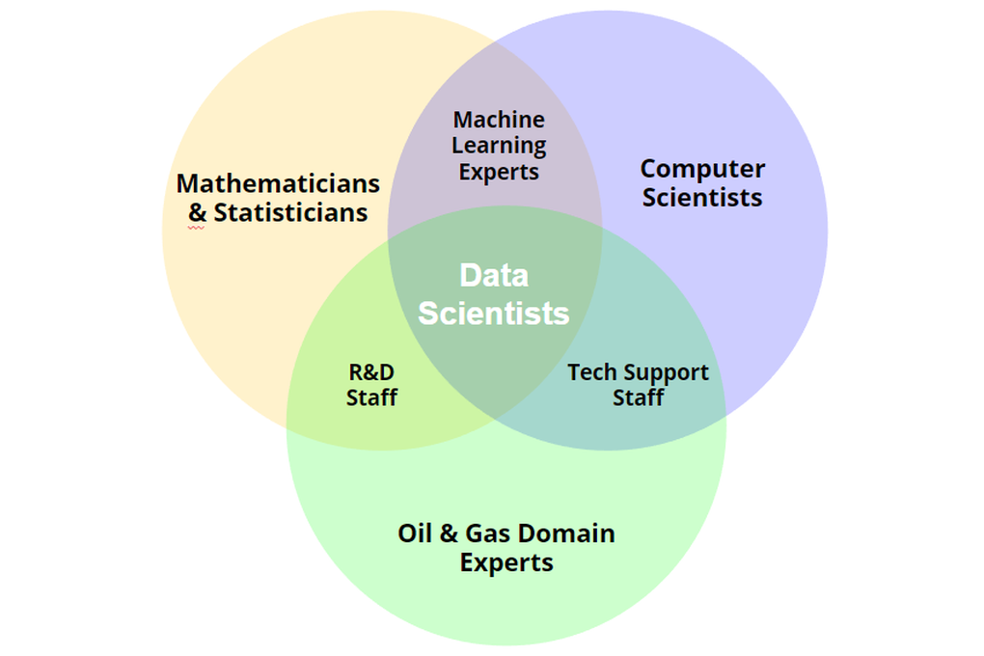

**Figure 1 :Data Science**

Mathematical principles are essential to data science because they facilitate pattern recognition and algorithm creation. The application of such algorithms in data science requires a solid understanding of many concepts in probability theory and statistics. Mathematics plays an important role in Field of Data Science is shown in figure 1. [10]

**3.2 Mathematics in Artificial Intelligence:** The technology known as artificial intelligence (AI) has come to revolutionize many facets of our existence. Mathematics plays a fundamental part in the astounding advances and capabilities of artificial intelligence. The foundation of mathematics gives artificial intelligence (AI) systems the ability to reason, learn, and make wise judgments. Large-scale data processing, analysis, and interpretation are made possible by machines thanks to mathematics, which forms the foundation of AI models and algorithms [11]. Developing machine learning algorithms requires an understanding of concepts from statistics, probability theory, calculus, and linear algebra. These algorithms recognize patterns, forecast outcomes, and categorize data using mathematical equations and functions. For example, the architecture of neural networks, the fundamental units of deep learning, requires a solid understanding of linear algebra. Neural networks employ matrices and vectors to encode and manipulate data, making it easier to do intricate calculations and provide AI systems the ability to derive valuable insights from data. An essential component in optimizing AI models is calculus. Calculus is used in methods like gradient descent and backpropagation to reduce mistakes and modify the parameters of machine learning models. Artificial intelligence (AI) systems can learn from data and keep getting better at what they do thanks to certain mathematical principles. In artificial intelligence, probability theory and statistics are essential for tasks like computer vision, natural language processing, and decision making. The mathematical framework to measure uncertainty, examine evidence, and make decisions is provided by probability distributions, Bayesian inference, and hypothesis testing. AI requires mathematics to be applied in order for intelligent systems to be developed and successful. Mathematics gives AI algorithms the concepts and tools they need to process data, identify patterns, and make decisions. As AI develops and takes on new forms, mathematics and AI will continue to work together to open up new avenues for innovation and to open up new frontiers. AI has the potential to revolutionize industries, solve challenging problems, and improve our daily lives in amazing ways. Branches of Mathematics which are used in AI and Machine Learning are shown in figure 2.

Statistics & Probability

Linear

algebra

Machine

Learning

OptimizationMethod

Multivariable

Calculus

Figure 2 AI and Machine learning

**IV. CONCLUSION**

This paper discusses about role of Mathematics in various fields like Data Science and Artificial Intelligence. Mathematics is a crucial discipline in data science, focusing on structure, order, and relation. It is essential for machine learning algorithms, analysis, and data interpretation. Artificial intelligence (AI) has revolutionized various aspects of life, with its foundation in mathematics enabling systems to reason, learn, and make wise judgments. Mathematics includes branches like algebra, geometry, trigonometry, calculus, statistics, and probability. Understanding concepts from these fields is necessary for developing machine learning algorithms that recognize patterns, forecast outcomes, and categorize data. The symbiotic relationship between mathematics and AI opens new avenues for creativity and innovation. Mathematics has various branches, including algebra, calculus, geometry, trigonometry, statistics, and probability. Algebra studies abstract symbols and arithmetic operations, while calculus studies the accumulation of quantities and the rate of change of quantities. Geometry examines the dimensions, angles, sizes, and forms of everyday objects, with applications in physics, engineering, architecture, and the arts. Trigonometry deals with angle functions and their use in computations. Statistics and probability are key ideas in mathematics, focusing on chance and data handling. These disciplines are essential in everyday life. Mathematics is a crucial component of data science, as it supports the creation of algorithms and the recognition of patterns. It is essential for professionals in data science, as it is required for machine learning algorithms, analysis, and drawing conclusions from data. Four mathematical foundations are needed: Linear Algebra & Matrix, Calculus, Geometry, and Probability & Statistics. Mathematics also plays a significant role in artificial intelligence (AI), enabling large-scale data processing, analysis, and interpretation. Understanding these concepts is crucial for developing machine learning algorithms, such as neural networks, and optimizing AI models. Mathematics provides AI algorithms with data processing, pattern identification, and decision making tools, fostering innovation and enhancing daily life.

**Let’s assume the following dataset includes various machine learning models and their performance metrics:**

|  |  |  |  |  |  |  |  |
| --- | --- | --- | --- | --- | --- | --- | --- |
| **Model** | **Accuracy** | **Training Time** | **Dataset Size** | **Cross-Validation Score** | **Hyperparameters** | **Feature Count** | **Deployment Status** |
| Model A | 0.85 | 10 | 1000 | 0.84 | param1, param2 | 5 | Deployed |
| Model B | 0.9 | 15 | 2000 | 0.88 | param2, param3 | 6 | Not Deployed |
| Model C | 0.92 | 8 | 500 | 0.91 | param1, param4 | 4 | Deployed |
| Model A | 0.87 | 12 | 1500 | 0.86 | param1, param2 | 5 | Not Deployed |
| Model B | 0.88 | 14 | 2000 | 0.89 | param3, param2 | 6 | Deployed |
| Model C | 0.93 | 9 | 700 | 0.9 | param4, param1 | 4 | Not Deployed |
| Model A | 0.86 | 11 | 1200 | 0.85 | param1, param5 | 5 | Deployed |
| Model B | 0.91 | 16 | 2500 | 0.87 | param2, param3 | 6 | Not Deployed |
| Model C | 0.94 | 10 | 600 | 0.92 | param1, param4 | 4 | Deployed |

**REFERENCES**

[1]. Neethumol K. G&Priya Prakash (2021).The Role of Mathematics and Statistics in the Field of Data Science. International Journal of Scientific & Engineering Research Volume 12,Issue 3,March-2021 ISSN 2229 5518.

[2]. Dr Suresh Dara, SubhamSurmara, Sai Kiran Reddy, Kamala Vani & Aditya Sai Verma (2022). Role of Mathematics in Machine Learning. IRJMETS 4 (04),2543-2548.

[3]. Ward Cheney & David Kincaid (2009).Linear Algebra:Theory and Applications. The Australian Mathematical Society 110,544-550.

[4]. Andrew Grossfield (2013).Introducing Calculus to the High School Curriculum: Curves, Branches and Functions..2013 ASEE Annual Conference &Exposition, 23.815.

[5]. S-T Yau (2000).Review of Geometry and Analysis. Asian Journal of Mathematics 4(1), 235-278.

[6]. ShaliniSaxena (2015).Geometry and Trigonometry. Britannica Educational Publishing.

[7]. Vijay K Rohatgi& AK MdEhsanesSaleh(2015).An introduction to Probability and Statistics. John Wiley & Sons.

[8]. Seung-Woo Lee (2008).A study on role of Mathematics/Statistics in IT fields.Journal of the Korean Data and Information Science Society 19(4),1397-1408.

[9]. Foster Provost & Tom Fawcett (2013). Data science and its relationship to big data and data-driven decision making. Big data 1 (1),51-59.

[10]. Dirk P Kroese,ZdravkoBotev,& Thomas Taimre (2019).Data Science and machine learning: Mathematical and statistical methods. Chapman and Hall/CRC.

[11]. Gwo-Jen Hwang & Yun-Fang Tu (2021).Roles and Research trends of artificial intelligence in mathematics education: A bibilometric mapping analysis and systematic review. Mathematics 9(6),584.

[12]. George Gadanidis (2017).Artificial intelligence, computational thinking and mathematics education. The International Journal of information and Learning Technology 34(2), 133-139